**Дата**: 2.12.2024

**Клас**: 7-АБ

**Предмет**: англійська мова

**Тема:** CLIL 2. ART. Мистецтво штрихування.

**Мета:** : формувати навички вживання лексичних одиниць по темі; удосконалювати навички читання, аудіювання й усного монологічного мовлення; розвивати пізнавальні інтереси учнів; виховувати інтерес до самостійного пошуку потрібної інформації, а також загальну культуру учнів.

**Вчитель**: Руда Д.В.

Хід уроку

1.Greeting

Good afternoon, guys! I’m glad to see you. Are you ready to start our lesson? All set?

2. Wаrm up / Listening

Уважно слухати аудіо трек і дати відповідь на питання вчителя <https://www.youtube.com/watch?v=FJTad0pyB8U&t=114s> .

3. Speaking

Дати усно відповіді на питання :

Is your name in the telephone book? ? Why or why not?

What is an unlisted phone number?

What kind of phone numbers can you find in the yellow pages of a phone book?

How can you find someone's telephone number on the Internet?

Have you ever called for pizza delivery?

Have you ever called a business (airlines, ELI, auto repair, insurance, bank, etc.) for information?

Have you ever had a problem with your phone bill? What did you do?

How do you communicate with someone who is in another place/country?

Do you have a cellular/mobile phone?

Is it difficult to communicate to someone who doesn't speak English very well?

Cell phones

How many phone calls do you usually receive and make in one day?

Do receive phone calls when you are already engaged to another call?

Do you have a cell phone?

How many people in your family have a cell phone?

What cellphone company do you use?

How did you decide to use this company?

Are you happy with this company?

How long have you used that company?

About how many text messages do you send in a day?

Who pays for your cell phone?

What kind of cell phone plan do you have with your carrier?

Who is the youngest person you know who has a cell phone?

What kind of features does your cell phones have?

How long have you had a cell phone?

Why have you decided not to have a cell phone?

Is it in bad taste to leave your cell phone on when you are at a restaurant?

What are some of the advantages and disadvantages of cell phones?

Could you live without your mobile phone?

How much do you spend a month on your cell phone?

4. Повторення

Повторити ступені порівняння прикметників і прислівників. <https://www.youtube.com/watch?v=wXiD0FdON7k> (перегляд відео-пояснення)

**Повторити possessive pronouns:**

<https://wordwall.net/ru/resource/1791898/possessive-pronouns>

<https://wordwall.net/ru/resource/38856520/english/ef-elementary-1c-b>

<https://wordwall.net/ru/resource/52592500/possesive-pronouns-with-its>

<https://wordwall.net/ru/resource/14787623/english/my-her-his-its-our-their>

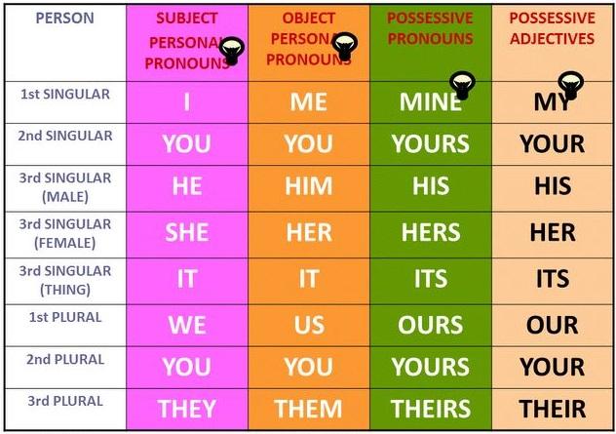

5. Writing

Виконати письмово впр 3 стр 45. Вправа 1 стр 46-47.

6. Homework

1. Виконати вправи E та F стр 107.

2. Вивчити форми **possessive pronouns.**